For the proof of done lab I have provided last few steps of the last task .

1. After we start infinite loop that sends the HTTP requests to the web sites hosted on the instances of Azure virtual machine scale set **az10408vmss0** we monitor the number of instances.   
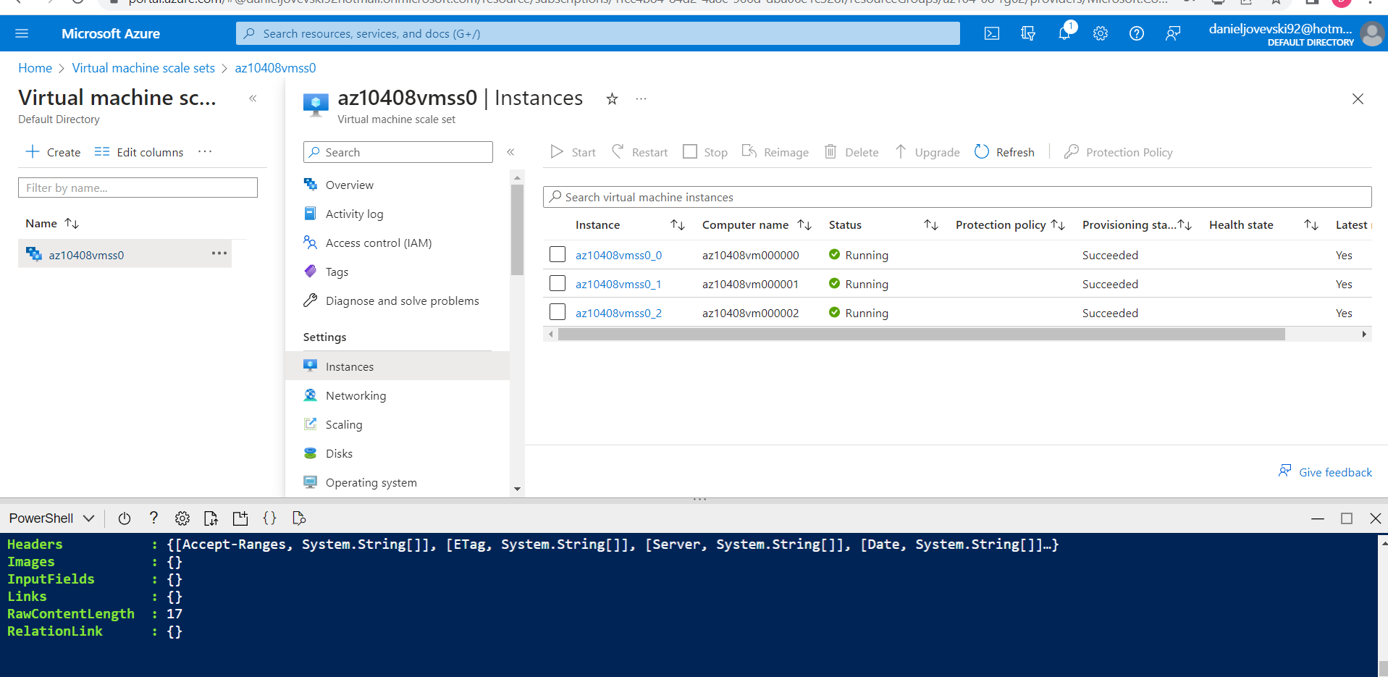

2. Once the third instance is provisioned, we determine its **Location**.

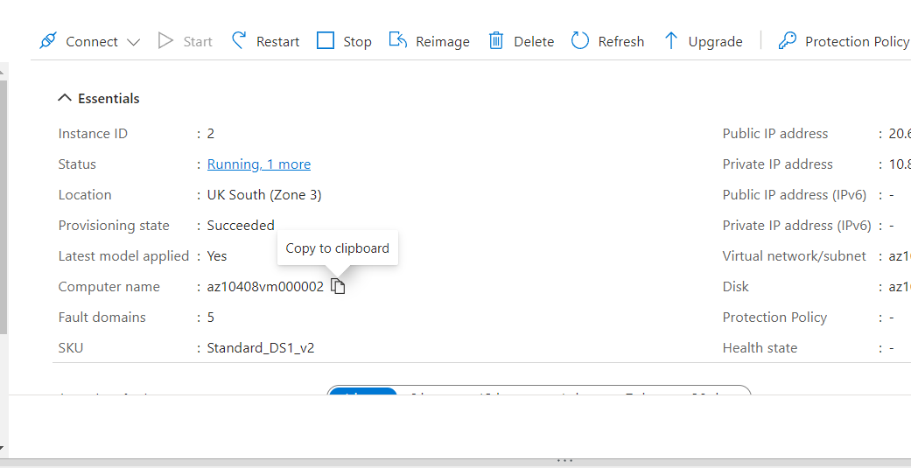

3. Upgrading the instances of the virtual machine scale set.

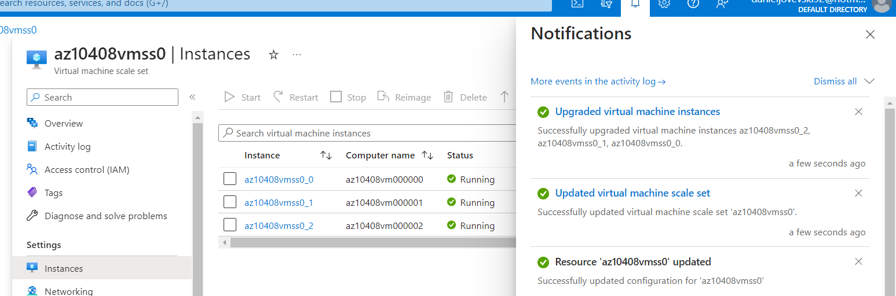

4. Uploading the script **az104-08-configure_VMSS_disks.ps1 and display the content of the script.**

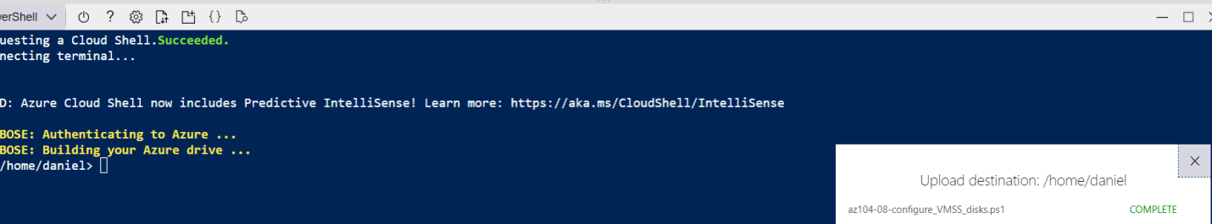

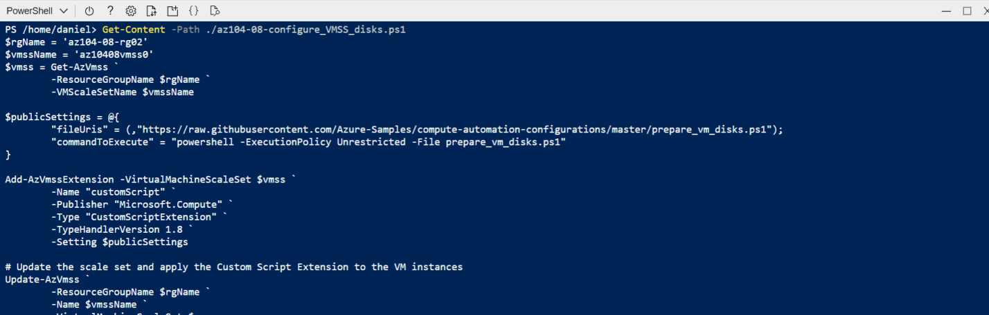

5. Executing the script and configure disks of Azure virtual machine scale set.

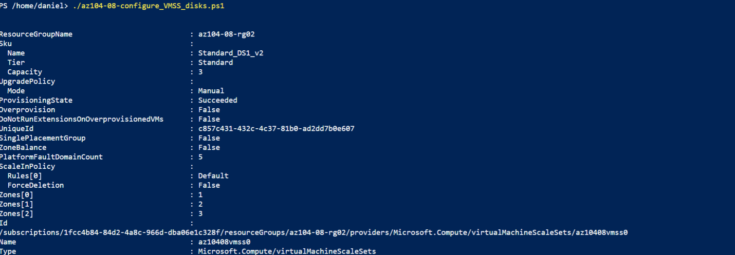

6. After that upgrading again the instances .

